**Pre-Requisites**

**Smart Lender - Applicant Credibility Prediction For Loan**

**Approval**

**Team ID: PNT2022TMID51373**

1.Anaconda navigator:

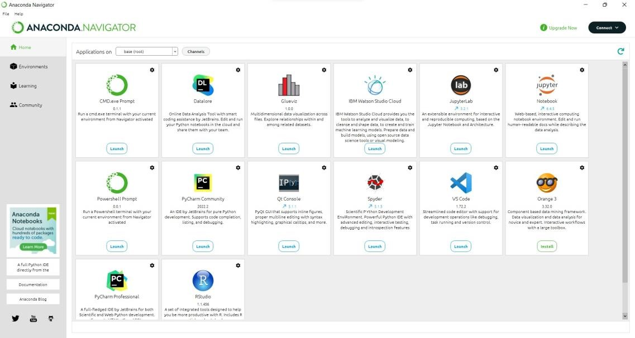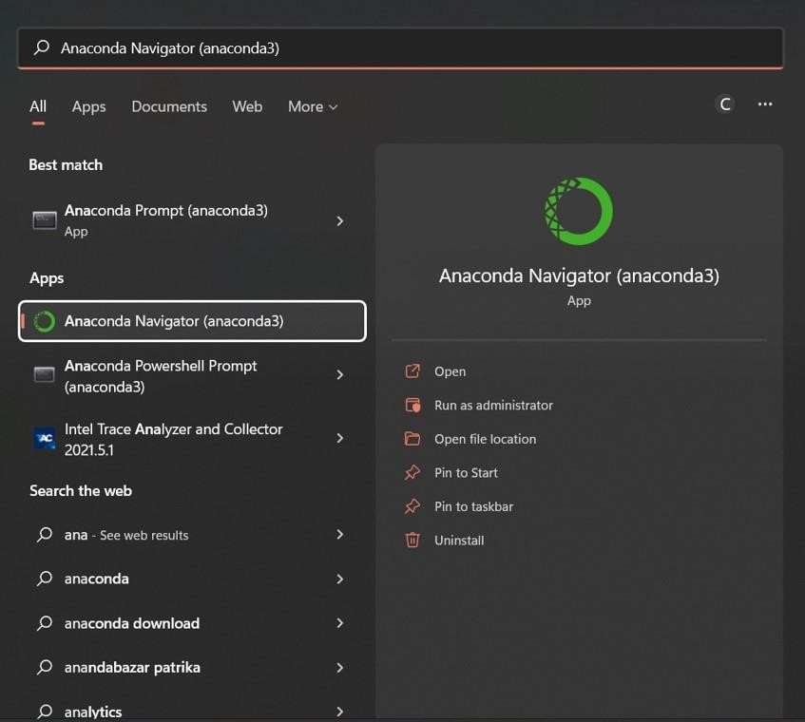

2.Jupyter:

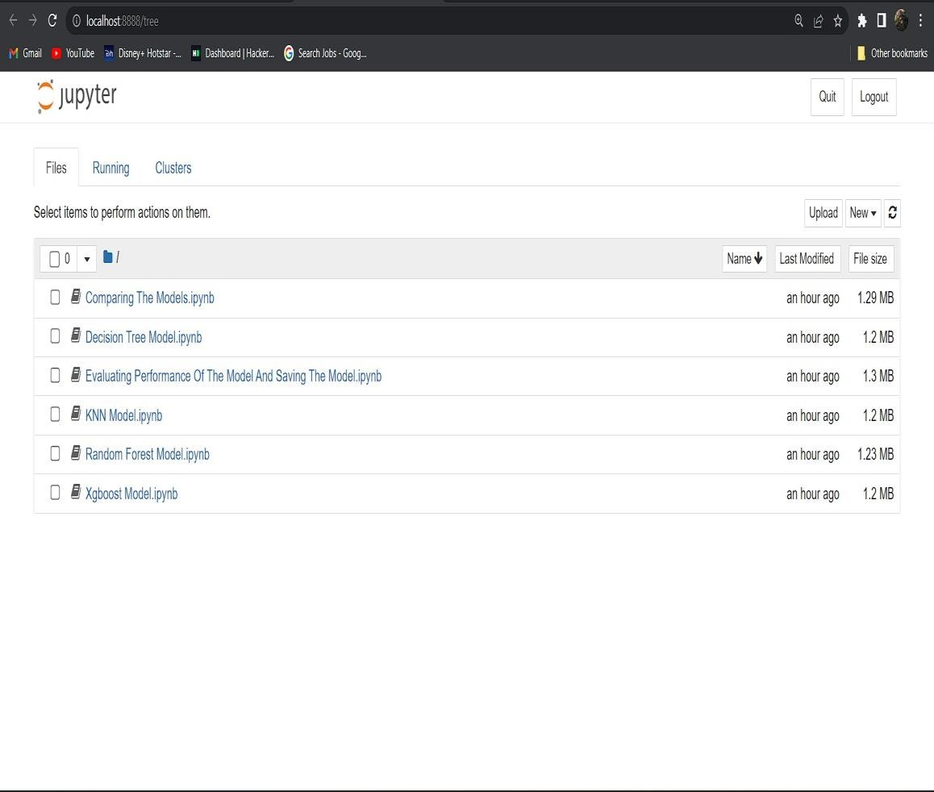

3.Python packages:

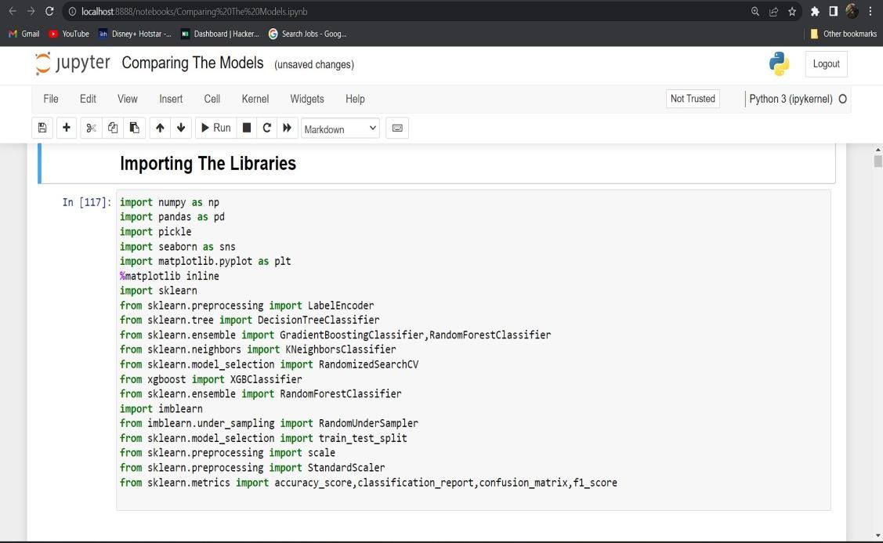

●Numpuy

●Pandas

●Matplotlib

●Pickle

●Scikit-learn ●Seaborn

4.IDE(VS code):

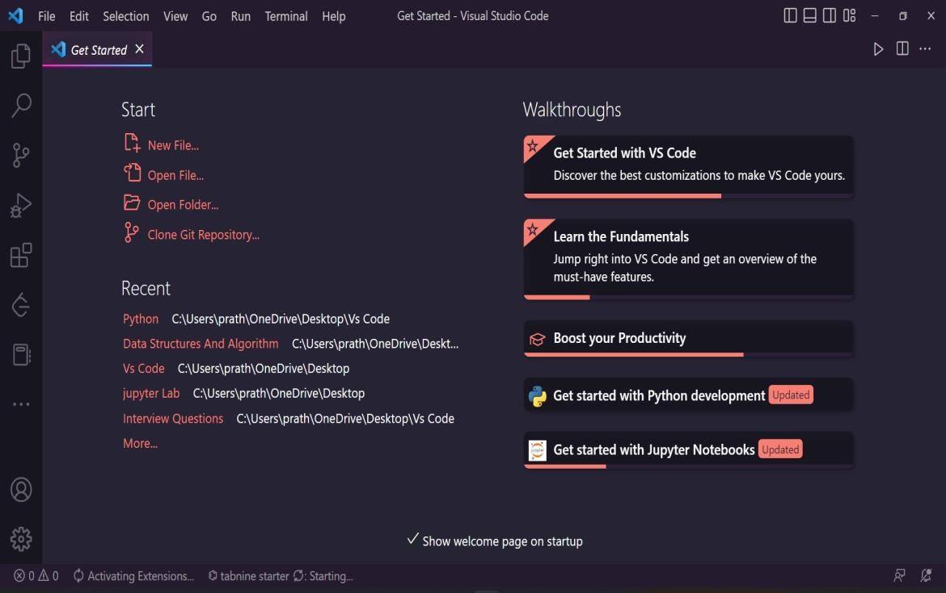

5.Dataset

6.Flask

7.Bootstrap

8.Virtual Environment

9.MY SQL